HW5

使用Pytorch

設計一個合理的方法，某A公司隔天預測股價

* 使用前10天資料做預測
* 80%做訓練20%做測試
* 均使用STT公司

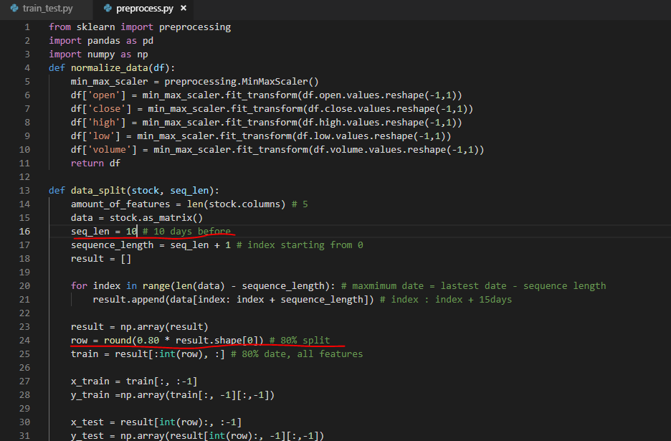

直接用助教提供的模型

畫出訓練loss與測試accuracy curves

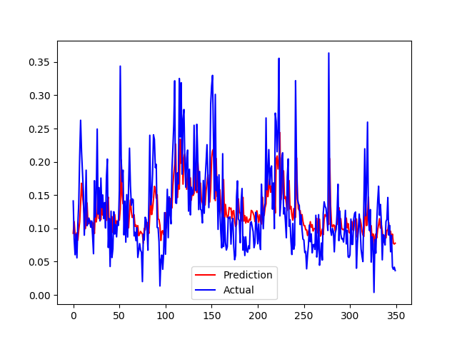

以測試資料每一天為單位:

data = stock.as_matrix()

epoch 0, loss 5.130434510647319e-05

epoch 1, loss 2.0575862436089665e-05

epoch 2, loss 1.0688127076718956e-05

epoch 3, loss 6.127215328888269e-06

epoch 4, loss 3.8885091271367855e-06

epoch 5, loss 2.573288384155603e-06

epoch 6, loss 1.702827944427554e-06

epoch 7, loss 1.1196422065040679e-06

epoch 8, loss 7.446545851053088e-07

epoch 9, loss 5.102380669086415e-07

epoch 10, loss 3.6380410506353655e-07

epoch 11, loss 2.7090220555692213e-07

epoch 12, loss 2.091930326741931e-07

epoch 13, loss 1.6542701075650257e-07

epoch 14, loss 1.3246750540929497e-07

epoch 15, loss 1.0657749527354099e-07

epoch 16, loss 8.592413536234744e-08

epoch 17, loss 6.952112840963309e-08

epoch 18, loss 5.656664470166106e-08

epoch 19, loss 4.631214522987648e-08

epoch 20, loss 3.8139987168506195e-08

epoch 21, loss 3.1655478238690193e-08

epoch 22, loss 2.644408425567235e-08

epoch 23, loss 2.2217784945155472e-08

epoch 24, loss 1.8746900920518783e-08

epoch 25, loss 1.582453279524998e-08

epoch 26, loss 1.3309034763153704e-08

epoch 27, loss 1.1124009269281032e-08

epoch 28, loss 9.204700113230047e-09

epoch 29, loss 7.540580604370462e-09

epoch 30, loss 6.0956484304597325e-09

epoch 31, loss 4.863309754910006e-09

epoch 32, loss 3.7965683929996885e-09

epoch 33, loss 2.8937074958435005e-09

epoch 34, loss 2.1187320786708597e-09

epoch 35, loss 1.4745824561401832e-09

epoch 36, loss 9.52818268729061e-10

epoch 37, loss 5.501101796312469e-10

epoch 38, loss 2.594726655757995e-10

epoch 39, loss 7.980288652120748e-11

epoch 40, loss 3.469446951953614e-12

epoch 41, loss 2.6047219936486954e-11

epoch 42, loss 1.42464040564505e-10

epoch 43, loss 3.4638980572765377e-10

epoch 44, loss 6.311831057814743e-10

epoch 45, loss 9.94194948589211e-10

epoch 46, loss 1.4257830471819943e-09

epoch 47, loss 1.911439007074023e-09

epoch 48, loss 2.4408342014226037e-09

epoch 49, loss 3.01028624249966e-09

使用Tensorflow

設計一個合理的方法，某A公司隔天預測股價

* 使用1970-2017的hp美股資料
* 使用前11000筆作為訓練資料；11000為測試資料

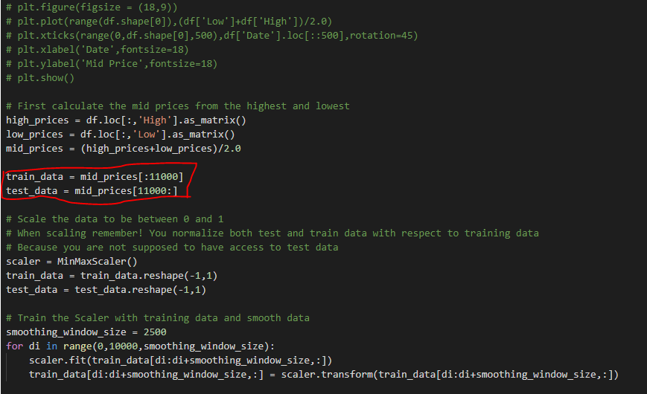

使用網路上找尋的模型

參考資料：<https://www.datacamp.com/community/tutorials/lstm-python-stock-market#download>

畫出訓練loss與測試accuracy curves

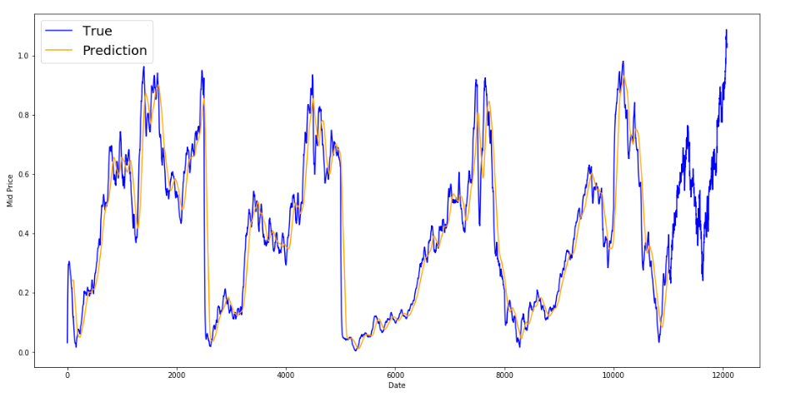

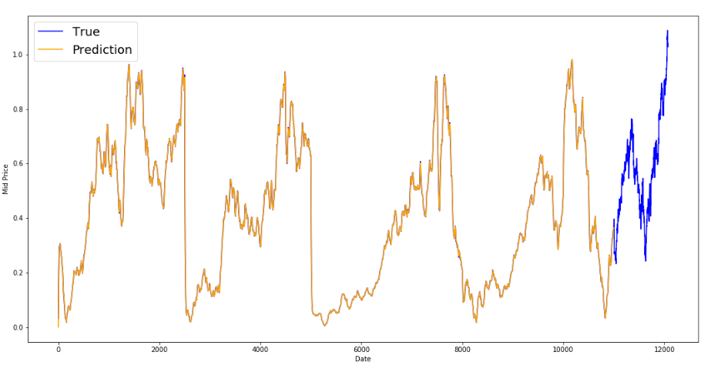

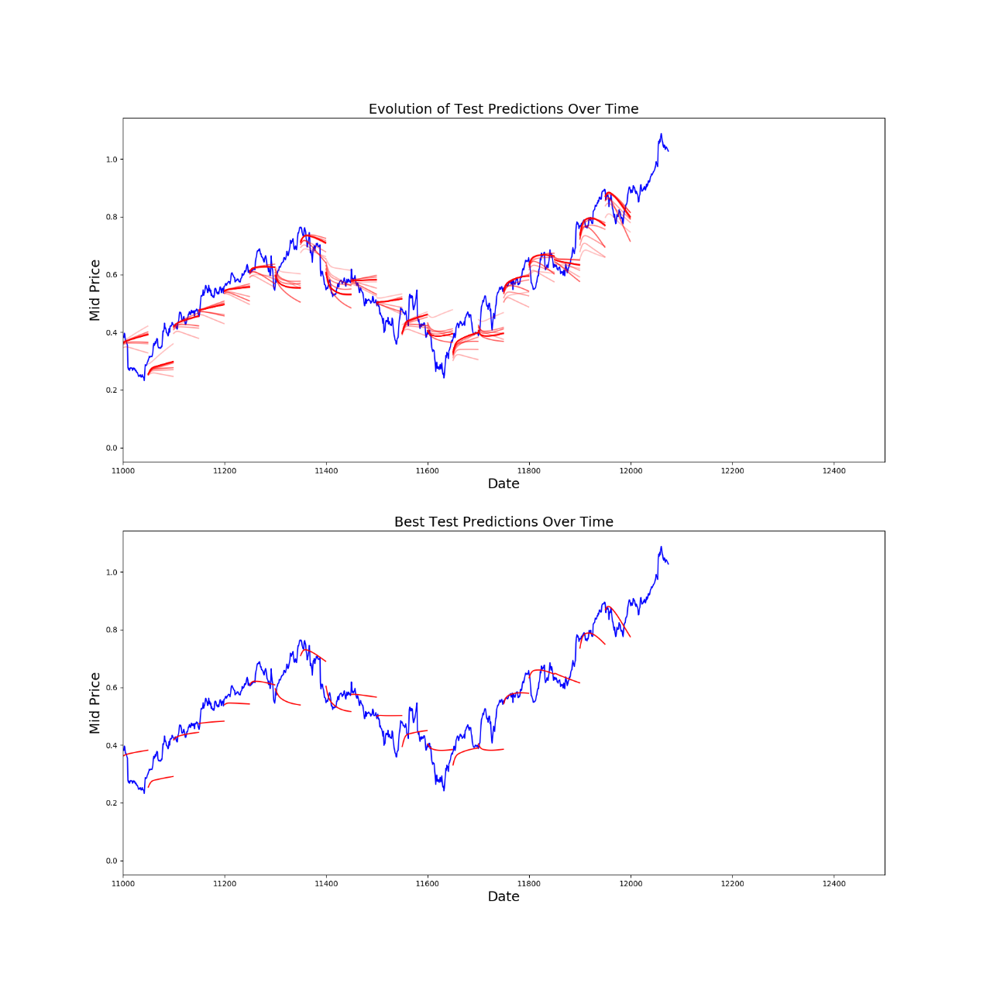

以測試資料每一天為單位:

Initialized

Average loss at step 1: 2.154257

Test MSE: 0.02947

Finished Predictions

Average loss at step 2: 0.172901

Test MSE: 0.00854

Finished Predictions

Average loss at step 3: 0.083486

Test MSE: 0.00302

Finished Predictions

Average loss at step 4: 0.066582

Test MSE: 0.00282

Finished Predictions

Average loss at step 5: 0.055656

Test MSE: 0.00283

Finished Predictions

Average loss at step 6: 0.050306

Test MSE: 0.00249

Finished Predictions

Average loss at step 7: 0.050464

Test MSE: 0.00234

Finished Predictions

Average loss at step 8: 0.049671

Test MSE: 0.00261

Finished Predictions

Average loss at step 9: 0.044614

Test MSE: 0.00261

Finished Predictions

Average loss at step 10: 0.044739

Decreasing learning rate by 0.5

Test MSE: 0.00235

Finished Predictions

Average loss at step 11: 0.041481

Test MSE: 0.00236

Finished Predictions

Average loss at step 12: 0.038258

Test MSE: 0.00264

Finished Predictions

Average loss at step 13: 0.037451

Decreasing learning rate by 0.5

Test MSE: 0.00256

Finished Predictions

Average loss at step 14: 0.036881

Test MSE: 0.00241

Finished Predictions

Average loss at step 15: 0.035269

Test MSE: 0.00252

Finished Predictions

Average loss at step 16: 0.037331

Decreasing learning rate by 0.5

Test MSE: 0.00238

Finished Predictions

Average loss at step 17: 0.041072

Test MSE: 0.00252

Finished Predictions

Average loss at step 18: 0.036354

Test MSE: 0.00258

Finished Predictions

Average loss at step 19: 0.037930

Decreasing learning rate by 0.5

Test MSE: 0.00247

Finished Predictions

Average loss at step 20: 0.037313

Test MSE: 0.00254

Finished Predictions

Average loss at step 21: 0.038118

Test MSE: 0.00245

Finished Predictions

Average loss at step 22: 0.037330

Decreasing learning rate by 0.5

Test MSE: 0.00243

Finished Predictions

Average loss at step 23: 0.035483

Test MSE: 0.00239

Finished Predictions

Average loss at step 24: 0.037280

Test MSE: 0.00242

Finished Predictions

Average loss at step 25: 0.035315

Decreasing learning rate by 0.5

Test MSE: 0.00241

Finished Predictions

Average loss at step 26: 0.036480

Test MSE: 0.00243

Finished Predictions

Average loss at step 27: 0.037379

Test MSE: 0.00241

Finished Predictions

Average loss at step 28: 0.036528

Decreasing learning rate by 0.5

Test MSE: 0.00240

Finished Predictions

Average loss at step 29: 0.038035

Test MSE: 0.00240

Finished Predictions

Average loss at step 30: 0.036815

Test MSE: 0.00247

Finished Predictions